

SRI LANKA INSTITUTE OF ADVANCED TECHNOLOGICAL EDUCATION
Higher National Diploma in Information Technology

HNDIT 4052
Programming Individual Project

Eranga Driving School
Management Platform

Supervisor:
Ms.K.G.D.De.A Wijesinghe

M.F Abdul Ahadh ACADEMIC YEAR: 2324
KUR/IT/2324/F/0083 YEAR II, SEMESTER II

Table of Contents

1. INTRODUCTION 4
1.1 Purpose of this Document 4
1.2 Scope of the System 4
1.3 Definitions and Acronyms 5
1.4 System Overview 5
2. GENERAL DESCRIPTION 6
2.1 Product Perspective 6
2.2 Product Functions 6
2.3 User Classes and Characteristics 7
2.3.1 Administrator (Hall Manager) 7
2.3.2 Customer 7
2.4 Features and Benefits 8
2.5 Assumptions and Dependencies 8
3. FUNCTIONAL REQUIREMENTS 9
3.1 User Authentication 9
3.2 Hall Management 9
3.3 Booking Management 9
3.4 Package and Service Management 10
3.5 Payment Management 10
3.6 Notification System 10
3.7 Reporting and Analytics 11
3.8 User Role Management 11
4. INTERFACE REQUIREMENTS 12
4.1 User Interface 12
4.2 Software Interface 12
4.3 Communication Interface 12
5. DESIGN CONSTRAINTS 13
6. NON-FUNCTIONAL REQUIREMENTS 14
6.1 Performance 14
6.2 Security 14
6.3 Reliability 14
6.4 Usability 14
6.5 Scalability 14
6.6 Maintainability 15
7. APPENDICES 16
7.1 Assumptions 16
7.2 Dependencies 16
7.3 Acronyms 16
7.4 References 17
8. Use Case Diagram 18
8. Entity Relationship Diagram 19
9. Class Diagram 20

1. INTRODUCTION

1.1 Purpose of this Document
This Software Requirements Specification (SRS) document provides a detailed description of the Hall Booking and Management System developed for Camilla Banquet Hall. The purpose of this document is to define the functional and non-functional requirements of the proposed system clearly and systematically.
This document acts as a formal agreement between the client, developer, and academic supervisor by explaining the expected behaviour, features, constraints, and operational flow of the system. It also serves as a guideline during the system design, implementation, testing, deployment, and maintenance phases of the Software Development Life Cycle (SDLC).
The document follows standard software engineering practices and is prepared for academic and development purposes.

1.2 Scope of the System
The Hall Booking and Management System is a web-based application developed to automate and simplify the hall reservation process for small and medium-scale event halls in Sri Lanka.
The system provides functionalities for:
- Real-time hall booking and availability checking
- Customer registration and booking requests
- Package and additional service management
- Payment tracking and sandbox payment simulation
- Automated notifications and reminders
- Revenue and booking report generation
- Admin and customer role management
The system is specifically designed for banquet halls such as weddings, receptions, birthday parties, and corporate functions.
The project focuses on improving operational efficiency, reducing manual workload, and enhancing customer experience through digital transformation.

1.3 Definitions and Acronyms
Acronym | Meaning
SRS | Software Requirements Specification
UI | User Interface
API | Application Programming Interface
REST | Representational State Transfer
CRUD | Create, Read, Update, Delete
OTP | One Time Password
Firebase | Google Cloud Backend Platform
HTTPS | Hypertext Transfer Protocol Secure
DB | Database
SDLC | Software Development Life Cycle

1.4 System Overview
The Hall Booking and Management System is designed as a centralized digital platform that replaces manual booking methods such as notebooks, spreadsheets, and phone-based reservation tracking.
The system allows customers to view hall details, check availability, submit bookings, and make advance payments through a sandbox payment environment. Administrators can manage bookings, approve reservations, monitor payments, configure packages and services, and generate business reports.
The application uses modern web technologies including React.js, Node.js, Firebase Firestore, and Firebase Authentication to provide a responsive, secure, and scalable environment.

2. GENERAL DESCRIPTION

2.1 Product Perspective
The Hall Booking and Management System is a standalone web application that integrates hall reservations, payment tracking, notifications, reporting, and customer management into one centralized system.
The system replaces traditional paper-based management processes with a modern digital solution that improves data organization and operational efficiency.
The system consists of two major user groups:
Admin (Hall Manager)
The administrator has full access to the system. Admin users can manage hall details, packages, bookings, reports, payments, notifications, and customer information.
Customer
Customers can browse available halls, submit booking requests, select packages and services, make advance payments, and monitor booking status updates.

2.2 Product Functions
The major functions of the system are described below:
1. User Authentication
The system provides secure login and registration facilities for both administrators and customers using Firebase Authentication.
2. Hall Management
Administrators can add, update, delete, and manage hall information including hall name, capacity, pricing, and availability.
3. Booking Management
Customers can submit hall booking requests while the system validates hall availability and prevents double bookings.
4. Package and Service Management
Administrators can create packages such as Silver, Gold, and Platinum and configure additional services including catering, decorations, DJ services, photography, and overtime charges.
5. Payment Management
The system tracks advance payments and remaining balances using a sandbox payment simulation environment.
6. Notification System
Customers receive booking confirmations, payment reminders, and event reminders through system alerts and email notifications.
7. Reporting System
Administrators can generate reports such as monthly revenue reports, booking statistics, payment summaries, and hall utilization reports.

2.3 User Classes and Characteristics

2.3.1 Administrator (Hall Manager)
The administrator is responsible for managing the entire system. The admin user is expected to have basic technical knowledge and understanding of booking management operations.
Admin users perform activities such as:
- Managing halls and packages
- Monitoring bookings and payments
- Generating reports
- Updating availability schedules
- Approving or rejecting booking requests

2.3.2 Customer
Customers are users who wish to reserve halls for events such as weddings or receptions. Customers are expected to have basic computer and internet literacy.
Customers can:
- Register and login
- View hall details and availability
- Submit booking requests
- Select packages and additional services
- Make advance payments
- Receive notifications and reminders

2.4 Features and Benefits
The proposed system provides several important benefits:
- Centralized digital booking management
- Real-time availability checking
- Prevention of double bookings
- Automated payment tracking
- Flexible package and service selection
- Secure and organized customer data management
- Automated notifications and reminders
- Dynamic revenue and booking reports
- Improved customer satisfaction and operational efficiency

2.5 Assumptions and Dependencies
The system assumes that:
- Users have internet connectivity
- Firebase cloud services remain operational
- Administrators regularly update hall and package information
- Customers provide accurate booking details
The system depends on:
- Firebase Authentication
- Firebase Firestore Database
- PayHere Sandbox payment environment
- React.js and Node.js runtime environment

3. FUNCTIONAL REQUIREMENTS

3.1 User Authentication
The system shall provide secure user authentication features.
Functional Requirements:
- Users shall register using email and password
- Users shall login securely using Firebase Authentication
- The system shall support role-based access control
- Invalid login attempts shall display error messages
- Passwords shall remain encrypted and secure

3.2 Hall Management
The administrator shall manage hall information through the admin dashboard.
Functional Requirements:
- Add new halls
- Update hall information
- Delete existing halls
- Manage hall pricing and capacity
- Upload hall images and descriptions
- View hall booking schedules

3.3 Booking Management
The system shall provide booking management functionalities for both customers and administrators.
Functional Requirements:
- Customers can submit booking requests
- The system shall validate date availability
- The system shall prevent double bookings
- Booking statuses shall include:
  - Pending
  - Approved
  - Confirmed
  - Completed
  - Cancelled
- Administrators can approve or reject bookings

3.4 Package and Service Management
The system shall support package-based and service-based pricing models.
Functional Requirements:
- Administrators can create packages such as Silver, Gold, and Platinum
- Each package shall contain different services and pricing
- Customers may optionally choose packages during booking
- Additional services such as catering, decoration, photography, DJ, and overtime can be added separately
- The system shall dynamically calculate pricing based on selected services and guest count

3.5 Payment Management
The system shall provide payment tracking functionality.
Functional Requirements:
- Customers can make advance payments
- The system shall calculate remaining balances automatically
- Payment status shall update after successful transactions
- Sandbox payment integration shall be used for demonstration purposes
- The system shall maintain payment history records
- Receipts and transaction details shall be stored securely

3.6 Notification System
The system shall provide automated notifications to improve communication.
Functional Requirements:
- Booking confirmation notifications
- Payment due reminders
- Event reminder notifications
- Notification dismiss and delete functionality
- Email and system alert support

3.7 Reporting and Analytics
The administrator shall have access to dynamic business reports and analytics.
Functional Requirements:
- Monthly revenue reports
- Weekly booking summaries
- Pending payment reports
- Hall utilization statistics
- Booking trend charts
- Dynamic dashboard analytics

3.8 User Role Management
The system shall implement role-based access control.
Functional Requirements:
- Admin users shall have full system access
- Customers shall have limited access
- Unauthorized users shall be restricted from admin features
- Firestore security rules shall enforce data protection

4. INTERFACE REQUIREMENTS

4.1 User Interface
The system shall provide a modern, responsive, and user-friendly interface.
User Interface Features:
- Responsive design for desktop, tablet, and mobile devices
- Luxury-themed UI design using emerald green and gold colors
- Separate dashboards for customers and administrators
- Interactive booking calendar
- Responsive mobile card layouts
- Toast notifications and alerts

4.2 Software Interface
The system integrates several technologies and services.
Technology | Purpose
React.js | Frontend development
Node.js + Express.js | Backend API development
Firebase Firestore | Database management
Firebase Authentication | User authentication
PayHere Sandbox | Payment simulation
Recharts | Analytics and data visualization

4.3 Communication Interface
The system uses secure communication protocols.
Communication Requirements:
- HTTPS protocol shall be used for secure communication
- JSON format shall be used for API communication
- Firebase cloud services shall handle real-time database communication

5. DESIGN CONSTRAINTS
The following design constraints apply to the system:
- The application must be web-based only
- React.js and Firebase must be used
- The system must support modern web browsers
- The system shall follow responsive web design principles
- GitHub shall be used for version control
- Secure coding standards shall be followed
- The project shall remain suitable for small and medium-scale hall businesses

6. NON-FUNCTIONAL REQUIREMENTS

6.1 Performance
- System response time shall remain below 3 seconds
- Calendar availability shall load within 1 second
- The system shall support multiple concurrent users

6.2 Security
- User passwords shall remain encrypted
- Role-based access control shall be enforced
- Firestore security rules shall protect customer data
- The system shall prevent unauthorized access and injection attacks

6.3 Reliability
- The system shall maintain data consistency
- Booking and payment records shall remain accurate
- Cloud database backups shall ensure data safety

6.4 Usability
- The interface shall be simple and easy to use
- Clear error messages and validation feedback shall be displayed
- The system shall support non-technical users

6.5 Scalability
- The system architecture shall support future expansion
- Additional halls and services can be added easily
- Future mobile application integration shall be possible

6.6 Maintainability
- The project shall use modular code organization
- Components and services shall be reusable
- Documentation shall be maintained properly
- Future updates and debugging shall be manageable

7. APPENDICES

7.1 Assumptions
- Users have internet access
- Administrators regularly update booking data
- Firebase services remain operational

7.2 Dependencies
- Firebase Authentication
- Firebase Firestore
- PayHere Sandbox API
- Node.js Environment
- React.js Framework

7.3 Acronyms
Acronym | Meaning
API | Application Programming Interface
UI | User Interface
DB | Database
SRS | Software Requirements Specification
HTTPS | Hypertext Transfer Protocol Secure
CRUD | Create Read Update Delete

7.4 References
- IEEE Std 830-1998 – Software Requirements Specification
- React Documentation – https://react.dev
- Firebase Documentation – https://firebase.google.com/docs
- Node.js Documentation – https://nodejs.org/docs
- Recharts Documentation – https://recharts.org
- Sommerville, I. (2016), Software Engineering
- Pressman, R.S. (2014), Software Engineering: A Practitioner’s Approach

8. Use Case Diagram

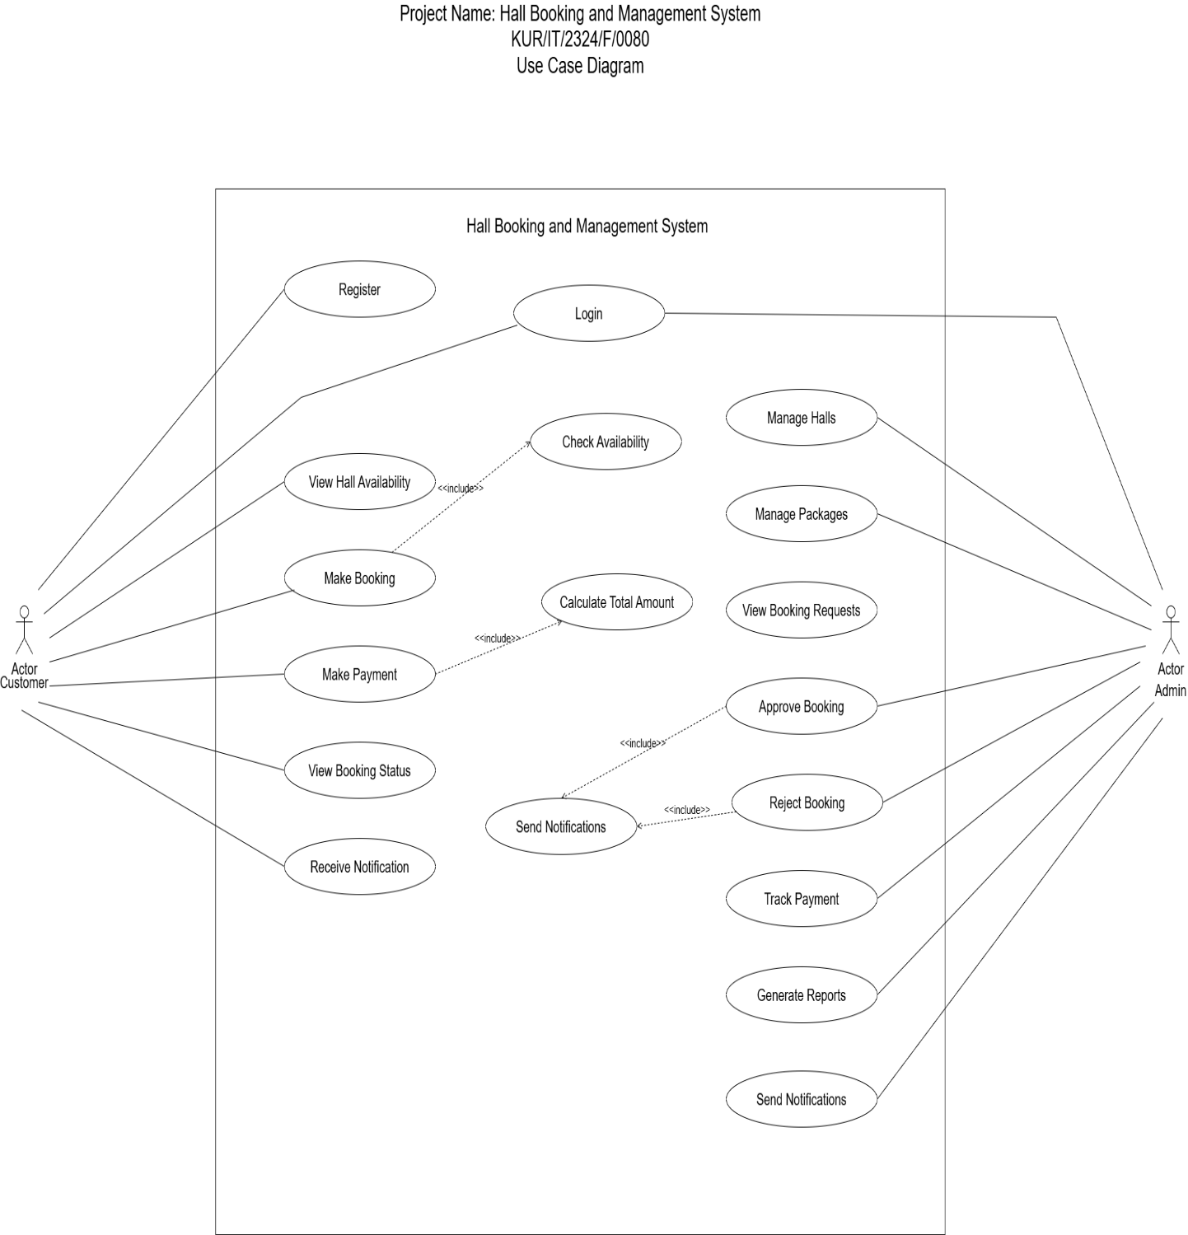

8. Entity Relationship Diagram

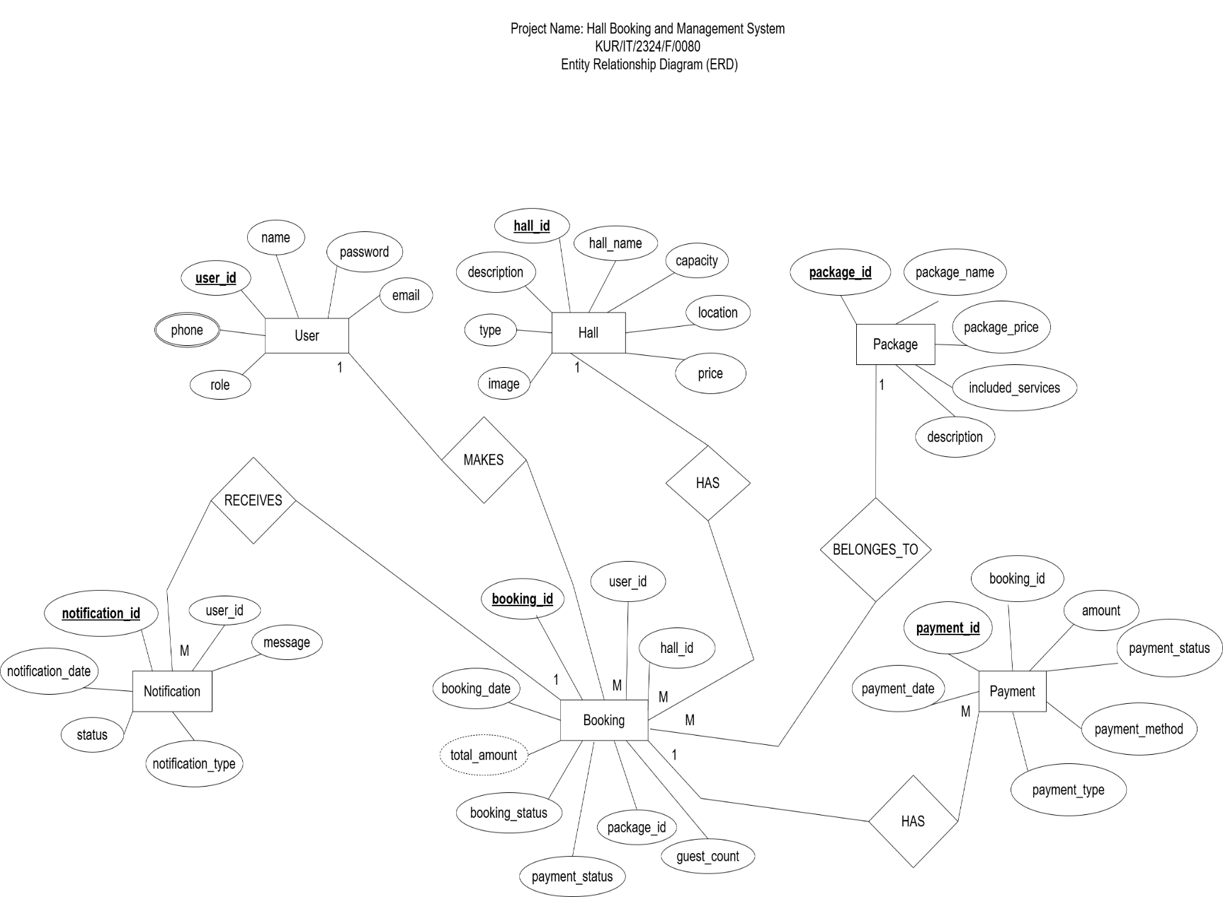

9. Class Diagram
